**Chapter Five**

1. **System Design Using Object-Oriented Paradigm**
   1. **Introduction**

This is the second phase of our project entitled Ambo University Online Examination System. In this phase we are going to verify brief aspect of phase one, and describe the phase two parts; detail description of chapter five which focused on Object-Oriented design and system containing class diagram, deployment diagram, state diagram, and relational persistence modeling diagrams, and chapter six which focuses on System implementation. In general, in this phase we will describe detail of our system design and implementation.

**Review of phase one (I)**

In the last phase, we have tried to describe the following: [1]

* **Chapter one**: Introduction

In this chapter we have discussed the background of the organization, statement of the problem, and objectives of the problem, scope and limitations of the, and feasibility of the project.

* **Chapter two**: current system.

In this chapter we have described about current system including its practices, players of the system, business rules and alternative solutions to the existing system.

* **Chapter three**: proposed system.

In this chapter we have stated the overview of the proposed system, functional and non functional requirements user interface hardware/software requirements, and security.

* **Chapter four**: system modeling using OO (object oriented) paradigm.

In this chapter we have discussed use case diagram and dynamic model which contain sequence and activity diagrams of the system.

In phase two (II) of the Ambo University Online Examination System, the following points will be discussed.

* **Chapter 5**: Object-oriented design and system Implementation.
* **Chapter 6**: System implementation.
  1. **Class modeling**

Class Modeling is design level that introduces changes to analysis class model based on implementation technologies. It focuses on the solution domain instead of the problem domain. It shows static nature of how the software is built.

* + 1. **Design modeling Class Diagram**

In object oriented system Analysis, Real world concepts are modeled into objects. Conceptual modeling hereby allows us to model these concepts which later involve in to a full-fledged class models. A class is a set of objects that share a common structure and a common behavior (the same attributes, operations, relationships and semantics).A class is an abstraction of real world items. When these items exist in the real world they are instance of the class and are referred to as objects and an object can be any person, place, and concepts or user interfaces. Classes are represented by rectangles with three sections. These are:

The top section is the name of the class.

The middle section contains the attributes which store information about an item

The bottom section contains the methods that show what are done on object or class.

The class Diagram below shows the class of our system, their inter relationship (including inheritance and association) and the operations and attributes of each classes. [2][3]

.



**Fig: 5.1** Class diagrams of AU OES

* + 1. **Class Diagram Description**

This section specifies the description of class diagrams contained in our system, Ambo University Online Examination System-AUOES. We have listed those descriptions as follows.

|  |  |  |  |
| --- | --- | --- | --- |
| **No** | **Field name** | **Data type** | **Description** |
| **1** | Name | VarChar(30)not null | Full Name of Administrator |
| **2** | ID | VarChar(20)not null | Identification of Admin |
| **3** | username | VarChar(20)not null | Username of Admin |
| **4** | password | VarChar(20)not null | Password of Admin |
| **Method:** **UpdateAdminAcc**(),DeleteAdminAcc() | | | |
| **UpdateAdminAcc**(): to change the profile of admin  **DeleteAdminAcc**(): to delete the account of the admin | | | |

**Table 5.1** class diagram description of attribute Administrator

|  |  |  |  |
| --- | --- | --- | --- |
| No | Fieldname | Data Type | Description |
| 1 | Name | Varchar(30) not null | Full name of the user (student, instructor, exam committee) |
| 2 | IDNo | Varchar(20) PRIMARY KEY, not null | Identification number of user |
| 3 | username | Varchar(20) not null | Username of User |
| 4 | password | Varchar(20) not null | Password of the user |
| 5 | Department | Varchar(50) not null | Department of the user |
| **Method**:CreateAccount(), DeleteAccount(), EditAccount() | | | |
| **CreateAccount():**enables admin to create user account for users | | | |
| **DeleteAccount():**enables admin to delete user account for users | | | |
| **EditAccount():**enables admin to edit user account for users | | | |

**Table 5.2** class diagram description of attribute User

|  |  |  |  |
| --- | --- | --- | --- |
| **No** | **Field name** | **Data Type** | **Description** |
| 1 | Faculty_id | VARCHAR(10)Primary key, NOT NULL | Identification number of faculty |
| 2 | Faculty_Name | VARCHAR(50)NOT NULL | Name of the faculty |
| **Method:** Add_Faculty(),DeleteFaculty()and Edit_Faculty() | | | |
| **Add_Faculty ():**used for adding faculty to the system | | | |
| **Delete_Faculty ():**used for Deleting faculty from the system | | | |
| **Edit_Faculty ():**used for editing faculty of the system | | | |

**Table 5.3** class diagram description of Faculty management

|  |  |  |  |
| --- | --- | --- | --- |
| **No** | **Field Name** | **Data Type** | **Description** |
| 1 | Deptno | Varchar(20) PRIMARY KEY, NOT NULL | Identification number of department |
| 2 | Dept_Name | Varchar(50) NOT NULL | Name of the department |
| 3 | Faculty | Varchar(50) NOT NULL | Name Faculty the department found in |
| **Method: Add_Dept(), Edit_Dept(), Delete_Dept()** | | | |
| **Add_Dept():** enables admin to add the department  **Edit_Dept():** enables admin to edit department  **Delete_Dept():** enables admin to delete the department | | | |

**Table 5.4** Class diagram description of Department Management

|  |  |  |  |
| --- | --- | --- | --- |
| **No** | **Field Name** | **Data Type** | **Description** |
| 1 | CourseNo | Varchar(20) PRIMARY KEY, NOT NULL | Identification number of course |
| 2 | CourseTitle | Varchar(50) NOT NULL | Name of the course |
| 3 | Departmnet | Varchar(50) NOT NULL | Name Department the course found in |
| 4 | CreditHr | Number | Credit hour of the course |
| **Method: Add_Course(), Edit_Course(), Delete_Course()** | | | |
| **Add_ Course ():** enables admin to add the course  **Edit_ Course ():** enables admin to edit course  **Delete_ Course ():** enables admin to delete the course | | | |

**Table 5.5** Class diagram description of Course Management

|  |  |  |  |
| --- | --- | --- | --- |
| **No** | **Field Name** | **Data Type** | **Description** |
| 1 | ExamNo | Varchar(20) PRIMARY KEY, NOT NULL | Identification number of Exam |
| 2 | ExamType | Varchar(50) NOT NULL | Type of the exam |
| 3 | Question | Varchar(1000) NOT NULL | Questions of the exam |
| 4 | Answer | Varchar(1000)NOT NULL | Answer of the question of exam |
| 5 | Course | Varchar(50) NOTT NULL | The course exam prepared for |
| **Method: Add_Exam(), Edit_Exam(), Delete_Exam(), Check_ Exam()** | | | |
| **Add_ Exam ():** enables instructor to add the exam  **Edit_ Exam ():** enables instructor to edit exam  **Delete_ Exam ():** enables instructor to delete the exam  **Check_ Exam():** enables exam Committee to check exam | | | |

**Table: 5.6** Class diagram description of exam

|  |  |  |  |
| --- | --- | --- | --- |
| **No** | **Field Name** | **Data Type** | **Description** |
| 1 | Result_id | Varchar(20) PRIMARY KEY, NOT NULL | Identification number of Result |
| 2 | Result_Value | Number | Total Result of student |
| 3 | Exam | Varchar(50) NOT NULL | Exam for which result is to be calculated |
| 4 | Course | Varchar(50) NOT NULL | The course of the exam result is to be calculated |
| 5 | Student_Id | Varchar(20) NOT NULL | The identification number of student that result calculated for |
| **Method: See_Result(), Calculate_Result()** | | | |
| **See_Result():** enables instructor and student to see result of student  **Calculate_Result():** enables the system to calculate the result of student | | | |

**Table: 5.7** Class Diagram Description of Result

* 1. **Deployment Diagram**

UML deployment diagram show physical view of system, taking software into real world by showing how software gets assigned to hardware and how communicates. The deployment diagram shows how the software components, processes, and objects are deployed into the physical architecture of the system. It shows the configuration of the hardware units (e.g. Computers, communication devices, etc) and how the software components are distributed across the units. [2]

AUOES (Ambo University Online Examination System) is server client structure architecture, where clients access services offered by server. The deployment diagram is shown as follows.



**Fig 5.2** Deployment diagram of system

Description of the architecture of the system is described as follows.

Clients are responsible for:-

* Provide user interface to the user enabling to get services
* Receiving inputs from user
* Checking range of performance
* Initiating database transactions once all necessary data are collected.

Server responsible for:-

* Transaction performance
* Guaranteeing the integrity of data.
* Putting backup of the database
  1. **Persistence Modeling**

Persistence of our object can be achieved by relational database since it used as machine to make object persistent. It describes the persistent data aspect of software system. Our system includes the basic table that handles the data of system implemented using MySQL server.

**Mapping class and relational table**

Mapping refers how objects and their relationship are stored in relational database. [3] The mapping of the data to be persisted in our system is given as follows:

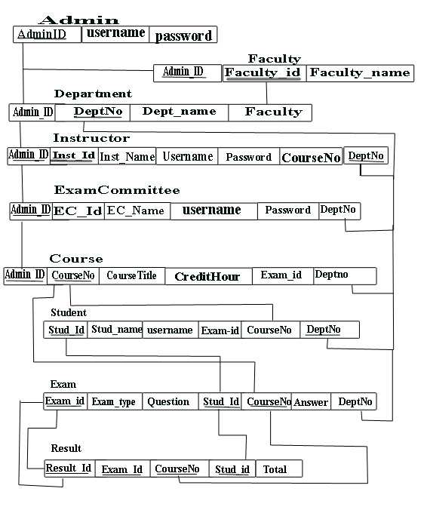

**Fig: 5.3** Persistence data management

* 1. **State chart**

UML state chart diagram is used to describe the behavior of an individual object as a number of states and transitions between these states. A state represents a particular set of values for an object. It has initial and final states. Transition is used as a progression from one state to another. Our project team has designed the following state chart diagram for our system. [2]



**Fig 5.4** State chart Diagram of user login



**Fig 5.5** State chart Diagram of user management on admin page



**Fig 5.6** State chart Diagram of exam management on instructor page



**Fig 5.7** State chart Diagram of exam management on Exam Committee page



**Fig 5.8** State chart Diagram of exam page for student



**Fig 5.9** State chart Diagram of result page for student and instructor

* 1. **User interfaces**

**User interface design** is the specification of the interaction between the system users and a system. The process involves input mechanism design, output mechanism design, and navigation mechanism.

* **Navigation mechanism** is part of user interface that takes the user form one part of the system to the other user system. That includes menus or links, buttons, icons, dialog boxes etc.
* **Input design** is about designing a form and its controls for GUI system.
* **Output design** is about designing reports like detailed, summarized, exceptional, graph, chart, text document report and extra.

In our system the menus that are functioning on the home page are the following:

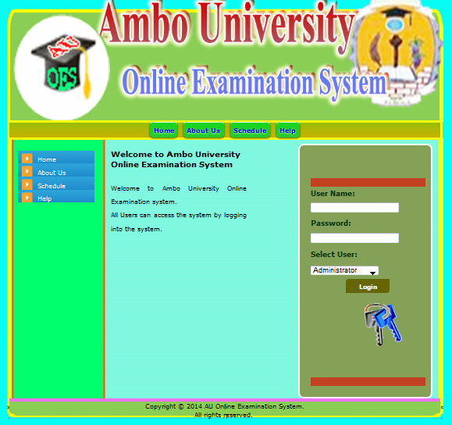

**Fig 5.10** Home Page of the System

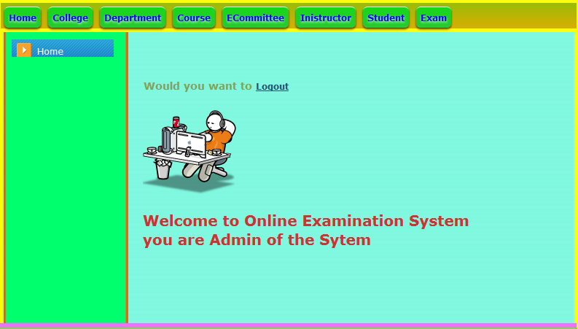

**Fig 5.11** Home Page for admin of the System

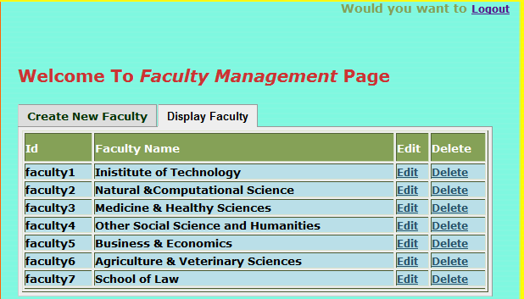

**Fig 5.12** Faculty Management Page of the System

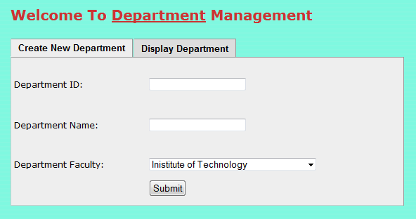

**Fig 5.12** Department Management Page of the System

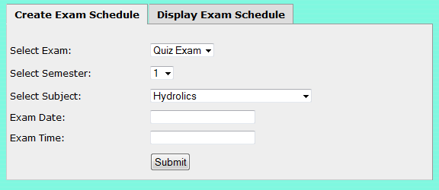

**Fig 5.13** Schedule adding page of the system

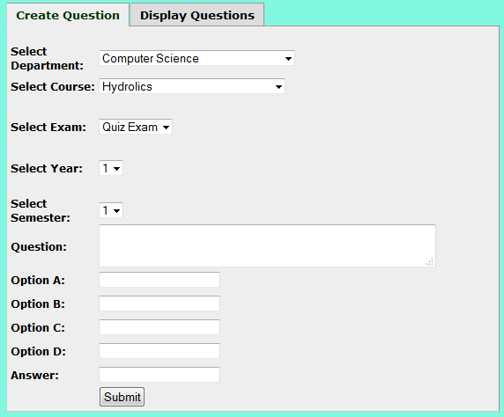

Fig 5.13 Exam adding page of the system

**Chapter Six**

1. **System Implementation and Testing**
   1. **Introduction**

In this chapter of our project we are going to explain aboutSystem Implementation and testing of the AUOES system.

* 1. **System Testing**
     1. **Testing Plan**

Testing is the process of finding the difference between expected behaviors specified by the system model and observed behavior of the implemented system. [2][4]

* + 1. **System Conversion**

**System Conversion** refers to drop or change the existing manual system and to start the new system. There are three types of conversion methods.

* **Parallel Conversion:** performing the previous style to work and the new system parallel until all necessary preparation is done to directly switch to the system.
* **Channel Conversion:** is the case when the registrar installs the new system small components, check whether it is satisfactory for giving a good service and slot in the system.
* **Straight Conversion:** the case when the existing system is dropped completely and the new system is driven in.[3]
  + 1. **Testing Techniques Methodologies**

The Proposed system can be tested through the following testing strategies.

* **Unit testing:** in this testing strategy the system components and modules are tested one by one. Each component where first identified and then tested.
* **System testing:** the architectural design of the system must be correct to have a correct system.
* **Volume testing:** most realistic type of testing .because it uses registrar data for which the system is developed for. It checks all necessary conditions applied in working environment.[3][4]

* 1. **Testing User Interface**

**Login to the System Testing:**

When user of the system does not enter Username and password it displays value required message.

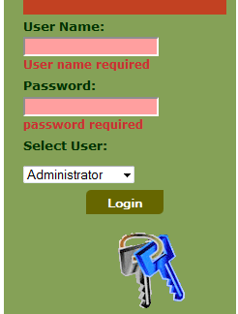

**Fig: 6.1** Login to the System Testing (Null value)

**Wrong Username or password entered:**

* Whenever users of the system entered the incorrect username or password the invalid data entry message will be displayed. If correct required page will be arrived.

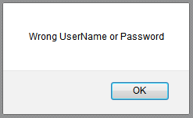

**Fig:6.2** Login to the System Testing (Incorrect user name or password)

**Admin page to add user to the system (missing Values) testing:**

* When admin do not insert all the required data of the user the system will display value required message and enables to enter data again. Since data entry enterface of all user is similar the same error message will be displayed.

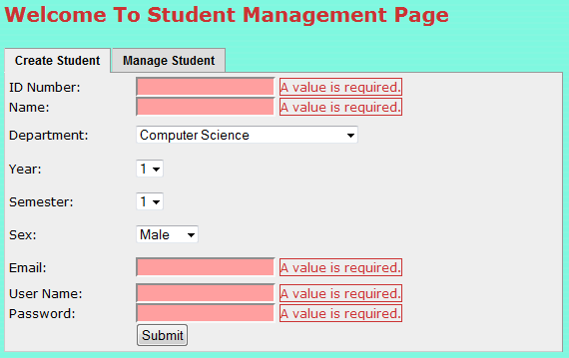

**Fig 6.3** Error message when to be entered to the system is not filled

**Admin page to add user to the system (correct value) testing:**

* When admin inserted all the values of user information to register correctly the success alert message will be displayed. It is similar for all users. The success message will be displayed when deletion and update of the user is correctly done.

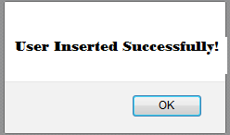 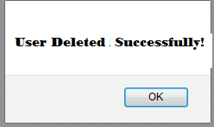 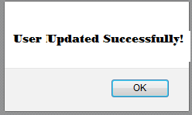

**Fig: 6.4** Success message for user adding deleting and updating done correctly

**Admin page to manage faculty, department and course to the system (missed value) testing:**

* While admin manages faculty, department and course if data missed while insertion, value required message will be displayed.

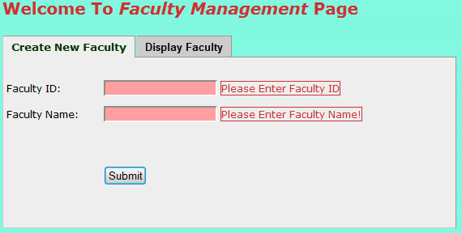

**Fig 6.5** Error message when required data is missed

**Admin page to manage faculty, department and course to the system (correct value) testing:**

* When admin entered the required values correctly the success message will be displayed.

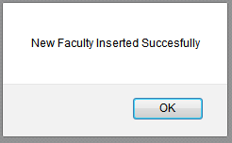

Fig 6.6 success message while managing faculty, department and course

* 1. **Conclusion**

Considering the drawbacks of the existing system and importance of new technologies the developed system, **Ambo University Online Examination system** is very useful to simplify examination system of Ambo University. Therefore a great striving played for this project of Ambo University Online Grade Report Generation System to be developed.

The system performs works better than existing system (usability, speed, efficiency and effectiveness). Security also included in this system developed and every user can access the required services. The system is also very useful in minimizing time and other utilities wastage.

AUOES system is developed to give the effective examination process that satisfies the need of all users in the system.

* 1. **Recommendations**

Current Ambo University Examination System is manual system or file based system and far away from advanced technology and information. Since this developed system is advanced our system have to recommend by Ambo University to accept and use this system because it is easy to use and save the time and resources’ for the university.

* 1. **References**

1. [1] AUOES documentation Phase I

2. [2] OOSAD Handout.

3. [3] “Fundamentals of Database Systems”, Third Edition, Ramez Elmasri

4. [4] Software Engineering (2009), “A Practitioner’s Approach”, Seventh Edition, Roger S. Pressman, Ph.D.

5. <http://www.tutorialspoint.com/mysql>

6. <http://www.tutorialspoint.com/php>

* 1. Acronyms

|  |  |  |
| --- | --- | --- |
| **No** | **Acronym** | **Meaning** |
| 1 | AUOES | Ambo University Online Examination System |
| 2 | ID | Identification number |
| 3 | Acct | Account |
| 4 | Dept | Department |
| 5 | GUI | Graphical User Interface |
| 6 | OOSAD | Object Oriented System Analysis and Design |
| 7 | PHP | Hypertext Preprocessor |

**Table 6.1** Table of Acronym and abbreviations used in documentation